Quantum Source Hybrid Photon-Atom Architecture

Background

To the best of our current understanding, utility-scale, fault-tolerant quantum computers will require millions of qubits. State-of-the-art qubits and quantum gates exhibit error rates of ${10}^{-3}$–${10}^{-4}$, roughly ten orders of magnitude higher than the $∼{10}^{-12}$ error rates required for useful quantum computing applications. Bridging this “quantum chasm” will require encoding quantum information into fault-tolerant, error-corrected logical elements, often requiring up to a thousand physical qubits to achieve the necessary logical error rates. As a result, a quantum algorithm requiring a few thousand ideal qubits may require on the order of ${10}^{6}$ physical qubits when implemented on realistically noisy hardware.
While having a large number of high-quality physical qubits is necessary, it is far from sufficient for fault-tolerant quantum computation. Equally important is connectivity – the ability to perform two-qubit entangling gates between different qubits, ideally regardless of their spatial separation. High connectivity facilitates the generation of quantum error-correction codes for constructing fault-tolerant logical elements and provides greater flexibility in fault-tolerant circuit compilation by removing spatial constraints on logical two-qubit gates.
Modern matter-based quantum computing platforms typically exhibit limited connectivity for both technical and fundamental reasons. For example, superconducting qubits are largely restricted to nearest-neighbor interactions due to wiring and coupling constraints in planar architectures. In trapped-ion systems, entangling gates can in principle be performed between distant qubits within the same chain, but their scalability is limited by motional mode crowding and the resulting degradation of gate performance. Furthermore, the number of matter-based qubits that can be maintained within a single controlled environment is typically limited. Consequently, scaling to millions of qubits will likely require modular architectures composed of multiple qubit-containing units. Establishing reliable connections between such modules poses an additional and significant challenge.
At present, photonic qubits appear to avoid many of the scaling limitations that affect matter-based quantum computing platforms. In their simplest implementations, quantum information can be encoded in the polarization of a photon or in a dual-rail encoding. Photonic qubits do not require specialized environments such as ultra-high vacuum or cryogenic temperatures, and most single-qubit operations can be realized using linear optical components. Moreover, photons interact only weakly with their environment and are therefore relatively robust against decoherence.
However, purely photonic approaches are not without their challenges. First, producing single photons in a controlled and deterministic manner remains difficult, and many currently available sources are probabilistic or suffer from limited efficiency and indistinguishability. Second, photons propagate at the speed of light and are difficult to store without specialized quantum memories; as a result, purely photonic architectures are naturally suited to measurement-based quantum computing (MBQC). Perhaps the most significant challenge, however, is that photons cannot be deterministically entangled using linear optics alone. Consequently, photonic quantum computing architectures typically rely on probabilistic entangling operations such as fusion gates, which in their simplest form succeed with a probability of at most 50%. Generating the large cluster states required for MBQC therefore demands substantial boosting of the effective entanglement success probability, which incurs significant overhead in the number of required single photons and the associated fusion infrastructure. Nevertheless, once the challenge of photon entanglement is addressed, qubit connectivity becomes effectively unrestricted, significantly clarifying the path toward fault-tolerant quantum computation.

QS proposed solution, or why yet another modality?

In the Quantum Source approach, the challenge of deterministic photon-photon entanglement is not addressed directly but instead circumvented by introducing two types of qubits: photonic (flying) qubits and atomic (stationary) qubits, and by establishing entangling CZ gates between them.
At the heart of our system is a single ⁸⁷Rb atom trapped inside a high-finesse optical cavity tuned near the D1 or D2 transition. The atom-cavity system operates in a high-cooperativity regime, such that for appropriately prepared atomic and photonic states the probability of interaction between the photon and the atom inside the cavity approaches unity. In particular, a high-fidelity CZ gate is implemented using a modified Duan-Kimble protocol, assisted by external laser control fields.
In the next section, we describe the main quantum protocols required to implement a quantum computer based on this system. For now, however, we assume that the necessary building blocks are already in place and focus on the high-level architectural features that support its potential as a viable path toward fault-tolerant quantum computation.
In the QS architecture, a large fraction of the physical qubits are photonic. As in purely photonic approaches, computation is therefore naturally performed within the measurement-based quantum computing (MBQC) model. However, because atom-photon CZ gates can be implemented with near-deterministic efficiency, cluster-state generation avoids the exponential resource overhead typically associated with boosting probabilistic photonic entangling operations. In addition, the same atom-cavity system can serve as a high-efficiency on-demand single-photon source using vSTIRAP protocols, substantially reducing the overhead associated with photon generation.
The QS architecture provides effectively unrestricted qubit connectivity, enabling flexible implementations of advanced quantum error-correction codes (e.g., qLDPC codes) and facilitating the optimization of compiled fault-tolerant quantum circuits. Moreover, although in its simplest form the QS architecture requires comparable numbers of photons and atoms, the atomic qubits can be reset and reused after measurement. With appropriate resource-optimization techniques, this enables a reduction of more than an order of magnitude in the number of required cavities and the associated optical control infrastructure.
Finally, a major advantage of our approach over neutral atom and trapped-ion architectures is the ability to perform entangling gates and SPAM operations on nanosecond timescales (tens of nanoseconds), representing orders-of-magnitude speedups – particularly in measurement – and placing it in the same regime as superconducting qubits.

QS quantum hardware building blocks

Qubit space
The atomic qubit is encoded in two internal states of the ⁸⁷Rb ground-state manifold (Fig. 1). In our implementation, the $|1,-1⟩$ and $|1,1⟩$ levels define the logical $|0⟩$and $|1⟩$, respectively (see diagram). All other ground-state levels are treated as leakage states, whose population can provide useful heralding information for refining error models.

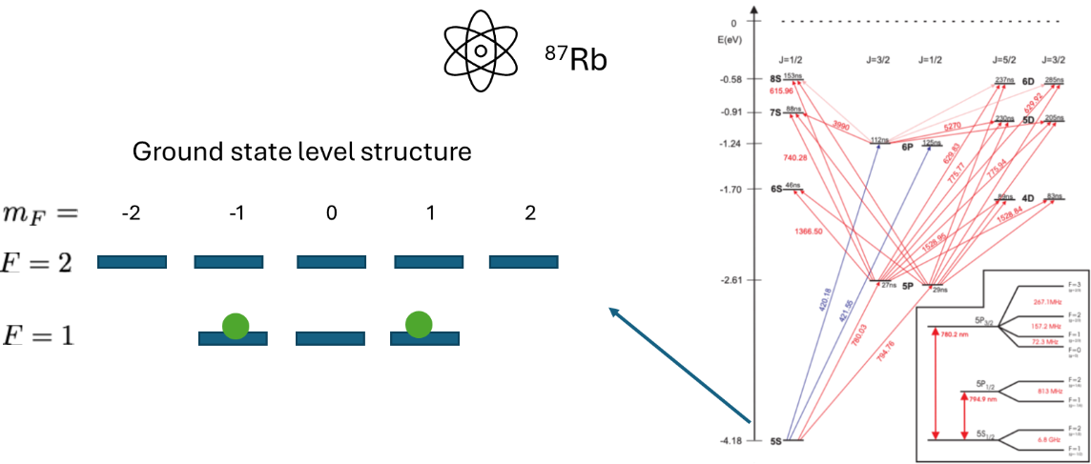
Fig. 1: QS atomic qubit

The photonic qubit is defined using dual-rail encoding, where a single photon occupies one of two optical modes representing $|0⟩$ and $|1⟩$. This choice is dictated by the atom-photon interaction scheme. While single-rail encoding is in principle possible, it typically requires additional active components or alternative photon-generation schemes (e.g., time-bin encoding). Other photonic degrees of freedom (e.g., polarization or temporal shape) play a secondary role.
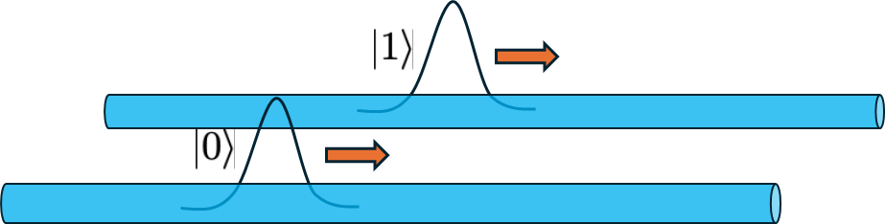
Fig. 2: QS photonic qubit. Our basic protocols are designed for dual-rail single-photon qubits. The protocols are generally not sensitive to the photon shape; Two-photon indistinguishability is not required

Single-site structure
A single site consists of a cavity-QED system with a single ⁸⁷Rb atom trapped inside an optical resonator, together with control fields for atomic manipulation, trapping, and cooling.
The cavity supports two optical modes and output channels matched to the atomic qubit states, enabling selective coupling between atomic states and orthogonal photonic modes. This allows efficient, cavity-enhanced implementation of all fundamental operations.
System performance is primarily determined by the atom-cavity coupling strength and intrinsic cavity losses, which set both the gate loss rates and the minimum achievable pulse duration. In principle, operation fidelities are not fundamentally limited by cavity losses.
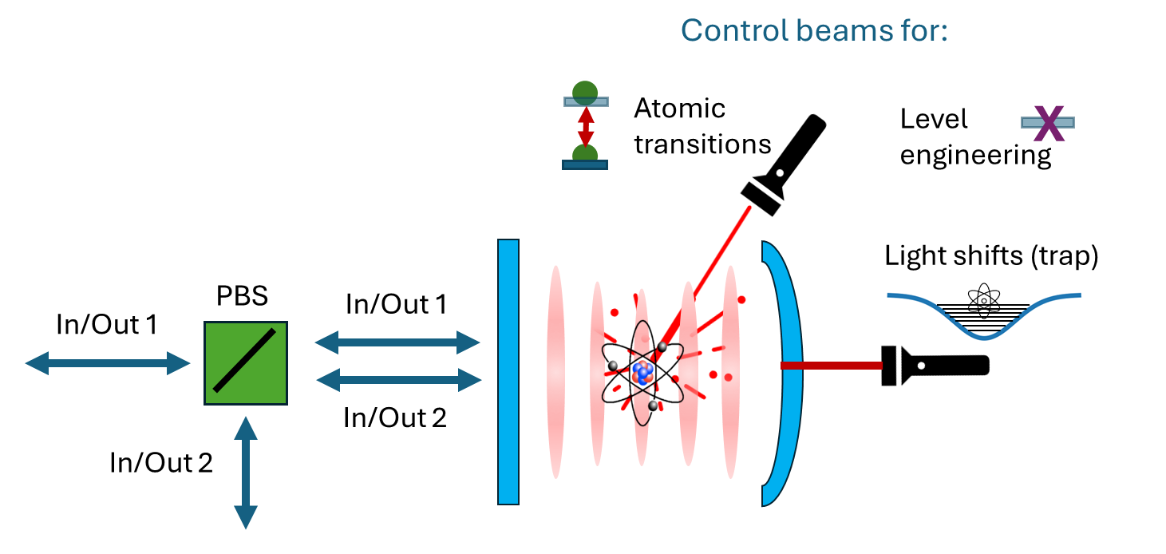
Fig. 3: Single site structure

Photon generation
The atom-cavity system functions as a near-deterministic single-photon source via vacuum-stimulated Raman adiabatic passage (vSTIRAP) in a $Λ$-type configuration (Fig. 4). An external control field drives one transition, while the cavity enhances the other, enabling coherent transfer between ground states and emission of a single photon. The energy gap suppresses re-excitation, yielding high-purity photon generation.
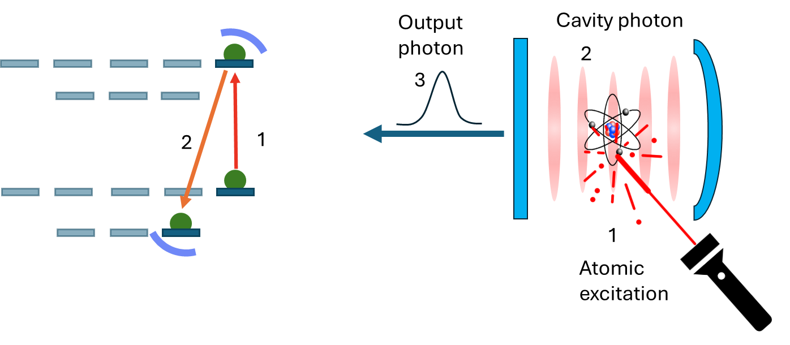
Fig. 4: Single photon generation
The photon temporal profile is controlled via the driving field, while cavity parameters determine the minimum pulse duration. Under adiabatic conditions, the protocol is largely insensitive to pulse shape, relaxing indistinguishability requirements compared to two-photon interference schemes.
Beyond single-photon generation, the same mechanism can produce atom-photon Bell states or map atomic states onto photonic qubits. These additional capabilities may be advantageous in certain protocols, although typically at reduced robustness.
Since photon-generation modules are identical to standard nodes, the architecture supports both dedicated sources and distributed (“permuted”) generation schemes, enabling system-level optimization.

State preparation and measurement (SPAM)

Atomic state preparation
State preparation proceeds in two steps. First, the atom is initialized to $|1,0⟩$, either generically or using prior state knowledge. Second, excitation to $|2,0⟩$ followed by cavity-mediated emission generates an atom–photon entangled state. Measurement of the emitted photon projects the atom into the desired qubit state.

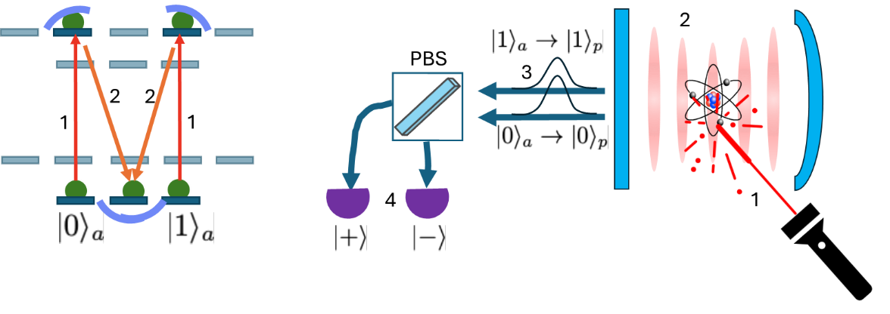
Fig. 5: Atomic state preparation
The emitted photon provides heralding, enabling post-selection of successful preparation. By choosing the photon measurement basis, arbitrary atomic states (e.g., $|T⟩$) can be prepared without direct single-qubit rotations.

Atomic state measurement
Measurement is performed by mapping the atomic qubit onto a dual-rail photonic mode via excitation to $|2,±1⟩$. The emitted photon encodes the qubit state and can be measured in an arbitrary basis or reused in subsequent operations.
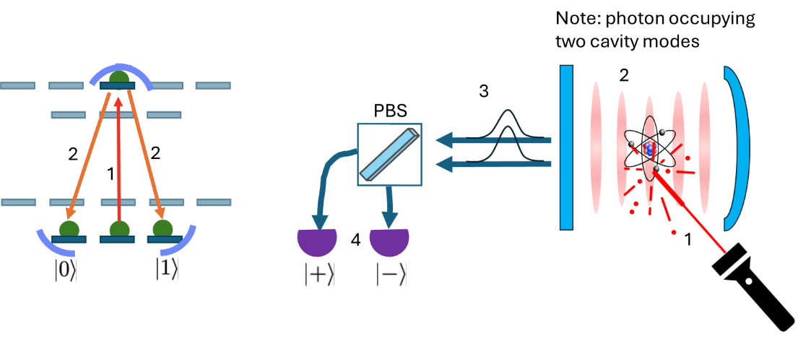
Fig. 6: Atom map-out and measurement
Preparation and measurement are designed to be complementary: both use the same optical path, minimizing phase errors, and the post-measurement atomic state naturally initializes the next cycle. Correlations between preparation and measurement outcomes can further enhance error modelling and decoding.

Entangling gate
The atom-photon CZ gate is implemented using a dual-rail variant of the Duan-Kimble protocol. A photon reflected from the cavity acquires a state-dependent phase shift: when the atom is in $|1⟩$, the photon gains a $π$-phase relative to the $|0⟩$ case. This realizes the transformation $|11⟩→-|11⟩$, with other basis states unchanged (Fig. 7).

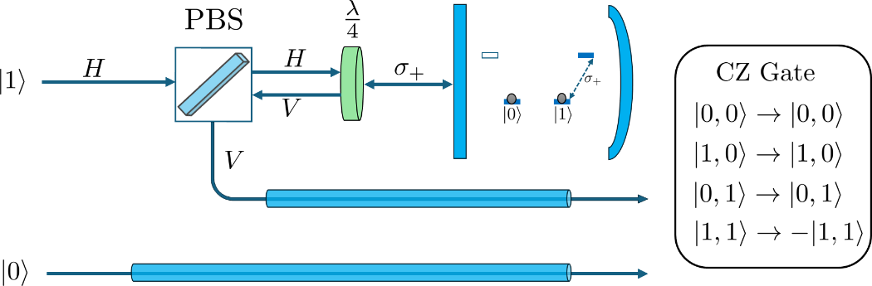
Fig. 7: CZ entangling gate

This conditional phase arises from selective coupling between the cavity mode and a single atomic qubit state. In practice, unwanted transitions – present in symmetric configurations – are suppressed using appropriately designed control fields, enabling effective level engineering.

Fault tolerance and MBQC with QS hardware

The basic fault-tolerant element is a logical memory channel. In simple terms, it represents a fault-tolerant realization of a quantum error-correcting code (QECC), implemented either in the circuit-based (CBQC) or measurement-based (MBQC) model.
Matter-based quantum computing architectures are typically implemented in the circuit model, where qubits persist throughout the computation and fault tolerance is achieved through repeated rounds of stabilizer measurements. These measurements extract error syndromes while preserving the encoded logical information, allowing physical errors to be detected and corrected over time. In leading approaches such as the surface code, this process generates a three-dimensional space–time structure, with the third dimension corresponding to successive rounds of syndrome extraction.
Photonic architectures are fundamentally different. Because photons propagate and are generally not available for repeated gate operations and measurement cycles, they are not naturally suited to circuit-based quantum computing in its standard form. Instead, photonic computation is more naturally formulated in the measurement-based model. In MBQC, the computation is carried out by a large, entangled resource (cluster) state, which is consumed layer by layer through measurement. Each measured layer is projected out of the computation, while the encoded quantum information is teleported forward to the next layer. At the same time, the measurement outcomes retain the stabilizer syndrome information needed for fault tolerance.
From this perspective, foliation provides the natural bridge between circuit-based and measurement-based fault tolerance. Repeated stabilizer-measurement cycles in the circuit model can be mapped onto successive measured layers (“time-slices”) of a foliated cluster state. In other words, what appears in circuit-based fault tolerance as repeated syndrome extraction in time becomes, in MBQC, the sequential measurement of a three-dimensional entangled resource through which logical quantum information is continuously teleported forward while error information is accumulated and decoded.
Within the foliated MBQC framework, two types of qubits arise: those that are connected only to other qubits within the same layer, and those that are also connected to qubits in the preceding and subsequent time layers. In analogy with CBQC, the former correspond to ancilla qubits used for syndrome extraction, while the latter play the role of data qubits, with the distinction that they are measured once all their entangling operations have been completed, and the quantum information they contained is teleported forward to the subsequent layer.
A canonical example of such a foliated construction is the Raussendorf-Harrington-Goyal (RHG) lattice, which realizes the surface code in the measurement-based model as a three-dimensional cluster state. In this framework, repeated stabilizer measurements are mapped to successive measured layers, while logical information is teleported forward through the lattice. The RHG lattice therefore provides a natural fault-tolerant logical memory channel for photonic architectures based on cluster-state consumption.
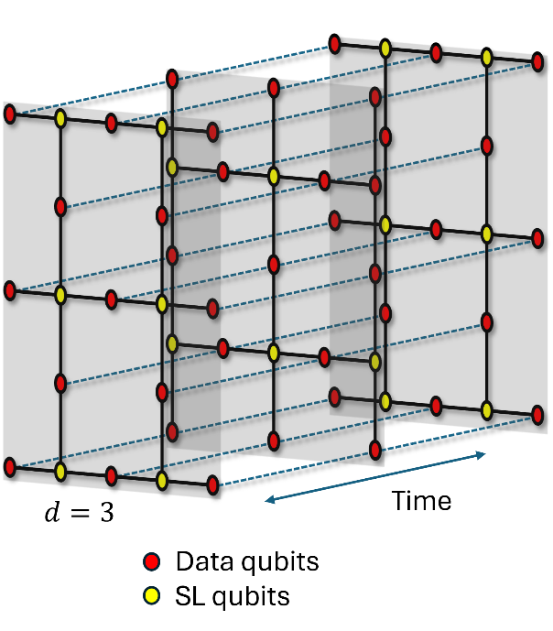
Fig. 8: RGH lattice example for $d=3$
Since CZ gates in QS hardware entangle photonic and atomic qubits, the resulting MBQC cluster state is inherently bipartite: photons are connected to atoms and atoms to photons. Thus, both atoms and photons in different positions play the roles of both “data qubits” (DQs) and “syndrome qubits” (SQs) – see Fig. 8. An important distinction is that while photons after measurement cease to exist, atoms can be reinitialized and reused later.
Taking these considerations into account, a range of generation schemes can be devised for implementing logical memory channels. As an example, a basic scheme for generating the RHG lattice on hybrid atom-photon hardware can be constructed as follows (Fig. 9).
In layer $n$, photons act as syndrome qubits (SLs) and perform four CZ gates within the layer with the corresponding data qubits (DQs), implemented by atoms. Since each atom participates in at most one CZ operation per time step and has degree two, all intra-layer CZ operations are completed in two rounds. Subsequently, the DQs in layer $n+1$ perform four CZ gates: two within their own layer and two connecting to layers $n$ and $n+2$. These inter- and intra-layer operations are completed in four rounds (green, orange, purple, and dark blue). The SLs are then introduced as photons in layer $n+2$, and the process repeats. Because atomic qubits can be reset and reused after measurement, this scheme can be executed cyclically, enabling continuous operation.

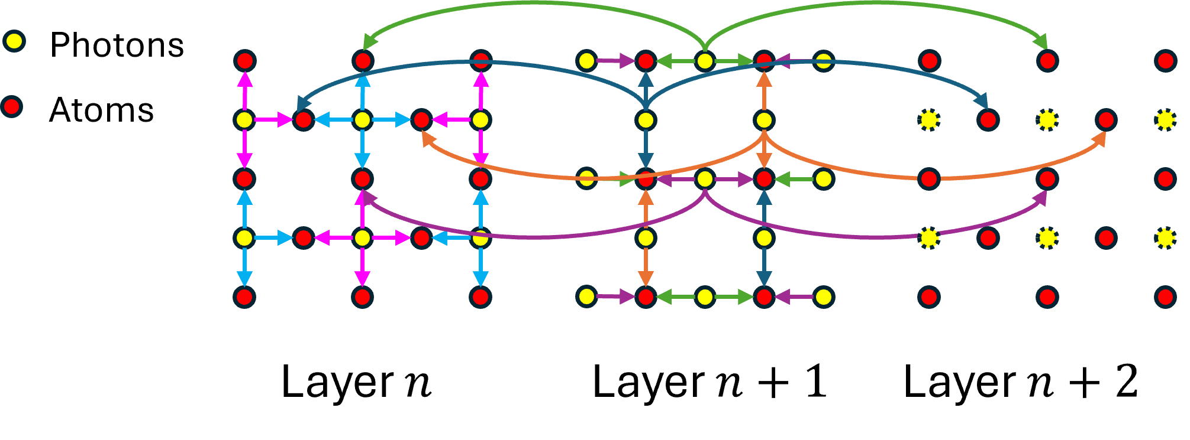
Fig. 9: RHG channel generation scheme with QS hardware. We show all intra-layer CZ gates, but for clarity only eight inter-layer CZ gates are shown.

